1)Install git.

2)Create a repo in github with README.md and .ignore file.

3)Clone the created repo to local.

4)Create two files in local repo.

5)Commit two files and push to central Repository.

6)Create a branch in local and create a sample file and push to central.

7)Create a branch in github and clone that to local.

8)Merge the created branch with master in git local.

9)Merge the created branch with master in github by sending a pull request.

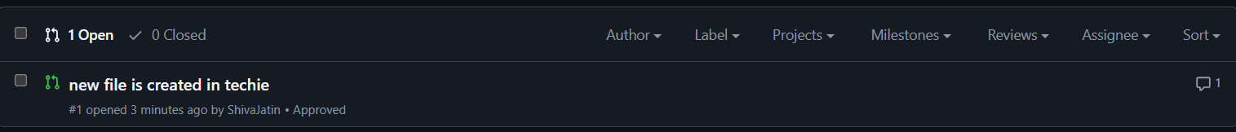

10)create a file in local and send that to branch in github.

11)clone only a branch from github to local.

12)create a file with all passwords and make that untrackable with git.

13)make a commit and make that commit reset without savings changes.

14)Revert a commited commit to the older version.

15)push a file to stash without savings the changes and work on another file.

16)undo the stash file and start working on that again.

17)generate a ssh-keygen and configure into github.

18)configure webhooks to github.

19)basic understanding of .git file.

-> When we initialise using git init

-> It prepares a directory to track changes within git.

-> Creates a hidden .git directory in the project

-> .git directory stores all the configurations to track the changes.

20)Check all the logs of git.

21)Rename the commit message.

22)Merge multiple commits into single commit

